UNIT 6
Lesson 7 – TIA'S YEAR
1 a) Look at Tia's year.
What does she do each month of a year.
Talk to your classmate.
Pogledaj kako izgleda Tijina godina. Što radi svaki mjesec?
Povedi razgovor sa svojim prijateljem iz klupa.

Month | What happens? | Month | What happens?
1 January  (siječanj) | goes skating | 7  July  (srpanj) | takes a holiday
2 February  (veljača) | writes Valentine cards | 8  August  (kolovoz) |   visits her grandma
3  March  (ožujak) | has a birthday party | 9 September  (rujan) | meets her friends
4  April  (travanj) | 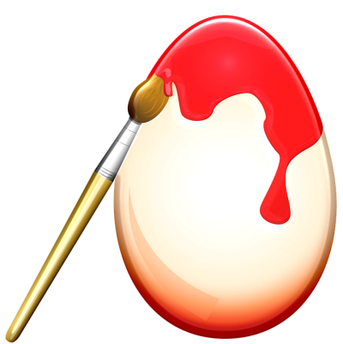paints Easter eggs | 10  October  (listopad) | puts on scary costumes
5  May  (svibanj) | goes hiking | 11 November  (studeni) | 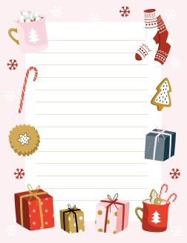  makes plans for Christmas
6  June  (lipanj) |   summer holidays start | 12 December  (prosinac) | buys presents

b) Look at the pictures.
Listen to your teacher read the expressions.
Point and say.
Pogledaj sličice. Poslušaj svog učitelja kako čita izraze.
Pokaži ih prstom i ponovi izraze.

1 GO SKATING
(ići na klizanje)
2 WRITE VALENTINE'S CARDS
(pisati čestitke za Valentinovo)
3 HAVE A BIRTHDAY PARTY
(imati proslavu rođendana)
4 PAINT EASTER EGGS
(bojati jaja za Uskrs)
5 GO HIKING
(ići na planinaranje)

6 SUMMER HOLIDAYS
(ljetni praznici)
7 TAKE A HOLIDAY
(otići na odmor)

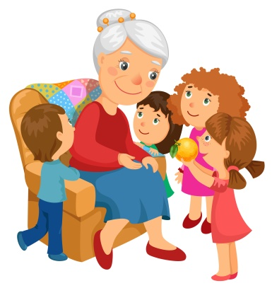
8 VISIT GRANDMA
(posjetiti baku)
9 MEET MY FRIENDS
(sresti prijatelje)

10 PUT ON SCARY
COSTUME
(odjenuti strašni kostim /
maskirati se)

11 MAKE PLANS FOR CHRISTMAS
(raditi planove za Božić)

12 BUY PRESENTS
(kupiti poklone)
c) Listen to Tia talk about her year (track 6.5) .
Point to the activities in the calendar above.
Poslušaj Tiju kako priča o svojim godišnjim aktivnoastima.
Prstom pokaži na aktivnost o kojoj Tija priča.

d) Look at Tia's calendar.
Finish the sentences about Tias's year.
Pogledaj Tijin kalendar. Dovrši rečenice o Tijinoj godini.

1 In January, Tia goes skating .
2 In February, Tia ________________________________ .
3 n March, Tia ________________________________ .
4 In April, Tia ________________________________ .
5 In May, Tia ________________________________ .
6 In June, Tia ________________________________ .
7 in July, Tia ______________________________________ .

8 In August, Tia ___________________________________ .
9 In Septemeber, Tia _______________________________ .
10 In October, Tia __________________________________ .

11 In November, Tia________________________________ .
12 In Decemeber, _________________________________ .

Project. Projekt.
Create your own calendar.
Draw or print out the pictures to glue in your calendar. Write down what you do each month.
Napravi svoj godišnji kalendar. Nacrtaj ili isprintaj pa nalijepi sličice aktivnosti za svaki mjesec. Nakon toga, napiši što radiš svaki mjesec

Month  (mjesec u godini) | What do you do?  (picture)  Što obično radiš?  (SLIKA) | What do you do?  (WRITE)  Što obično radiš?  (NAPIŠI)
January  siječan |  | I _______________  ________________  ________________  ________________  ________________  ________________ .
February  veljača |  | I _______________  ________________  ________________  ________________  ________________  ________________ .
March  ožujak |  | I _______________  ________________  ________________  ________________  ________________  ________________ .
April  travanj |  | I _______________  ________________  ________________  ________________  ________________  ________________ .
May  svibanj |  | I _______________  ________________  ________________  ________________  ________________  ________________ .
June  lipanj |  | I _______________  ________________  ________________  ________________  ________________
July  srpanj |  | I _______________  ________________  ________________  ________________  ________________  ________________ .
August  kolovoz |  | I _______________  ________________  ________________  ________________  ________________  ________________ .
Septemeber  rujan |  | I _______________  ________________  ________________  ________________  ________________  ________________ .
October  listopad |  | I _______________  ________________  ________________  ________________  ________________  ________________ .
November  studeni |  | I _______________  ________________  ________________  ________________  ________________  ________________ .
December  prosinac |  | I _______________  ________________  ________________  ________________  ________________  ________________ .

